Python Code Answers – All 12 Tasks
Student Details
- Name: K. Anshitha
- Register Number: 1924260262
- Slot: A
- Course Code: CSA0821
- Faculty Name: Keerthana S.

Task 1: Identify Data and Constants:
milk_litres = 10
rate_per_litre = 40
total_payment = milk_litres * rate_per_litre

print("Milk Litres:", milk_litres)
print("Rate per Litre:", rate_per_litre)
print("Total Payment:", total_payment)
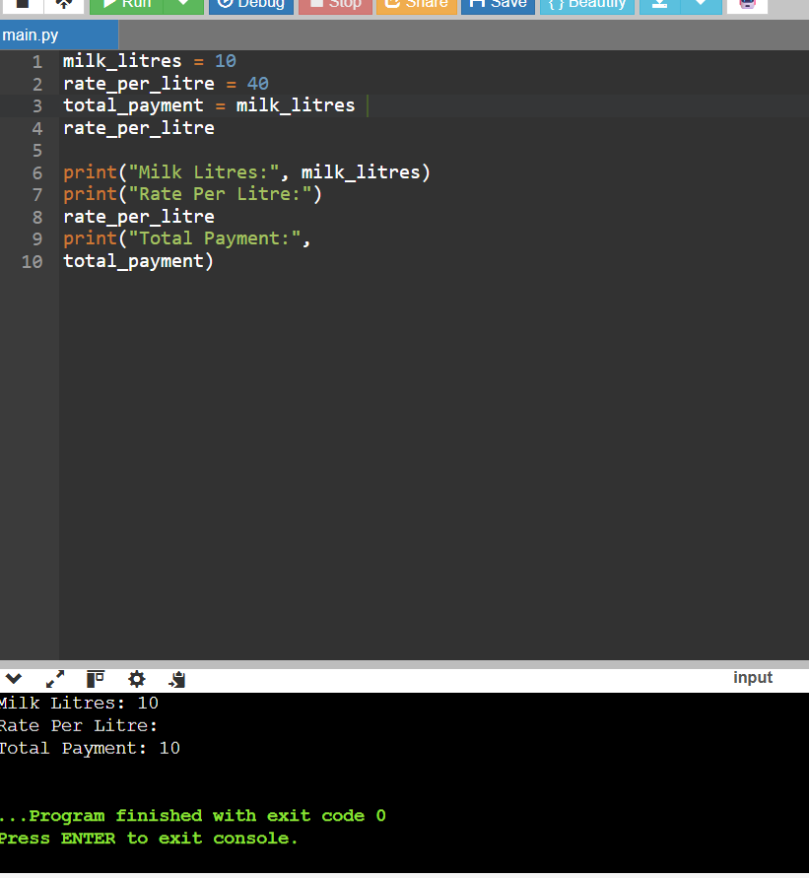

Task 2: Data Types and Decimal for Money:
from decimal import Decimal

milk_litres = Decimal("10")
rate_per_litre = Decimal("40.50")

total_payment = milk_litres * rate_per_litre

print("Total Payment: Rs.", total_payment)
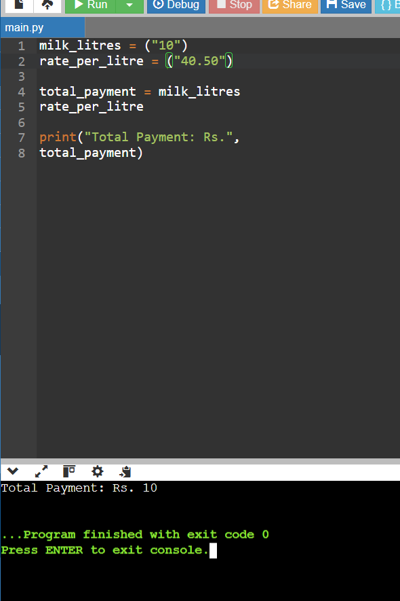

Task 3: Variables and Constants:
RATE_PER_LITRE = 40

milk_litres = 10
total_payment = milk_litres * RATE_PER_LITRE

print("Milk Litres:", milk_litres)
print("Rate per Litre:", RATE_PER_LITRE)
print("Total Payment:", total_payment)
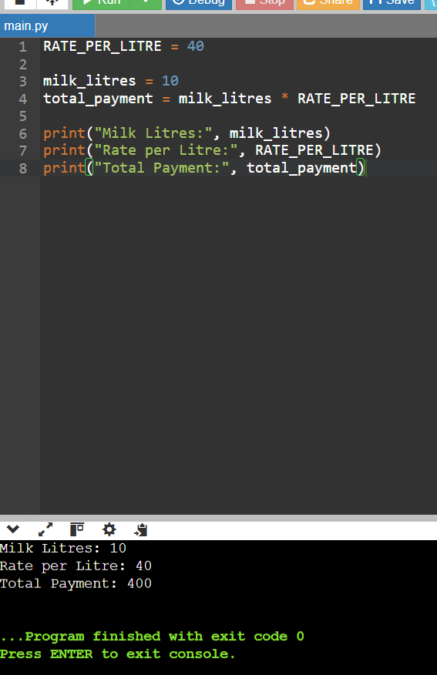

Task 4: Arithmetic Expressions:
milk_litres = 15
rate_per_litre = 40
bonus = 50

total_payment = (milk_litres * rate_per_litre) + bonus

print("Milk Payment:", milk_litres * rate_per_litre)
print("Bonus:", bonus)
print("Total Payment:", total_payment)
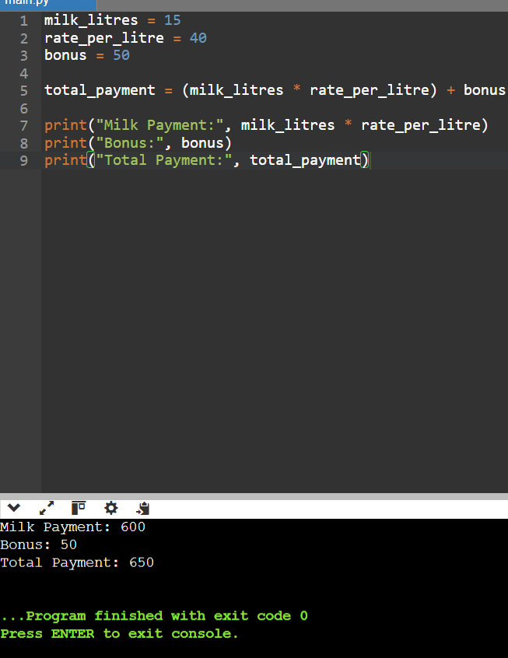

Task 5: Input, Type Conversion and Validation:
milk_litres = float(input("Enter milk quantity in litres: "))
rate_per_litre = float(input("Enter rate per litre: "))

if milk_litres >= 0 and rate_per_litre >= 0:
total_payment = milk_litres * rate_per_litre
print("Total Payment: Rs.", round(total_payment, 2))
else:
print("Please enter non-negative values.")
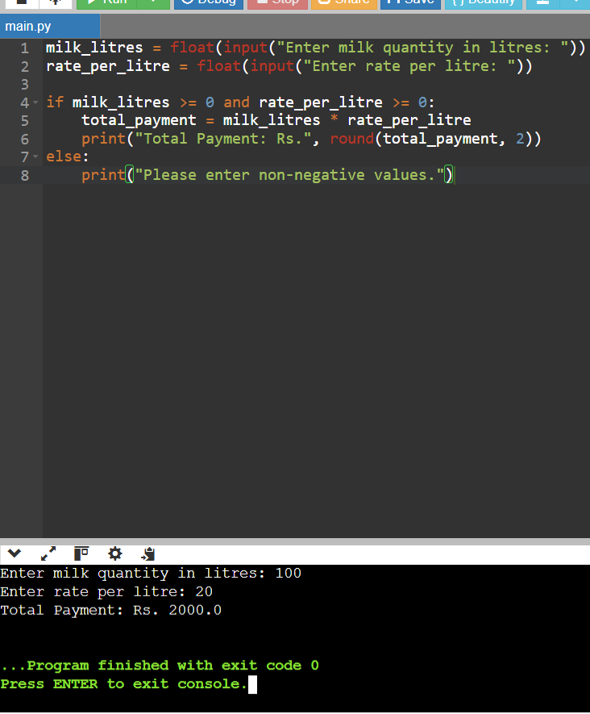

Task 6: Functions:
def calculate_payment(milk_litres, rate_per_litre):
return milk_litres * rate_per_litre

litres = float(input("Enter milk quantity: "))
rate = float(input("Enter rate per litre: "))

payment = calculate_payment(litres, rate)

print("Total Payment: Rs.", round(payment, 2))
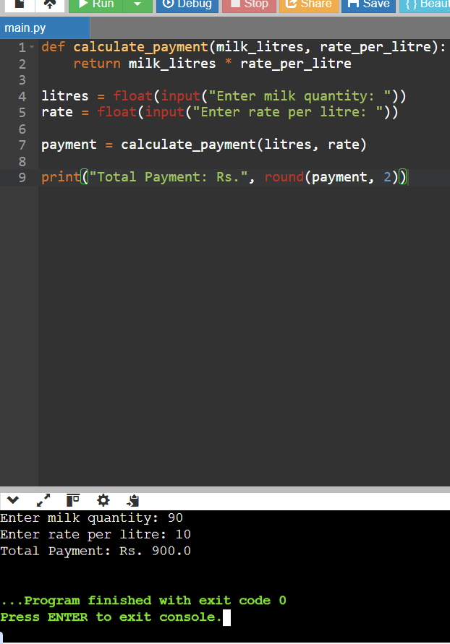

Task 7: Using a Module
import math

milk_litres = 12
rate_per_litre = 40

total_payment = milk_litres * rate_per_litre

print("Total Payment:", total_payment)
print("Rounded Payment:", math.ceil(total_payment))
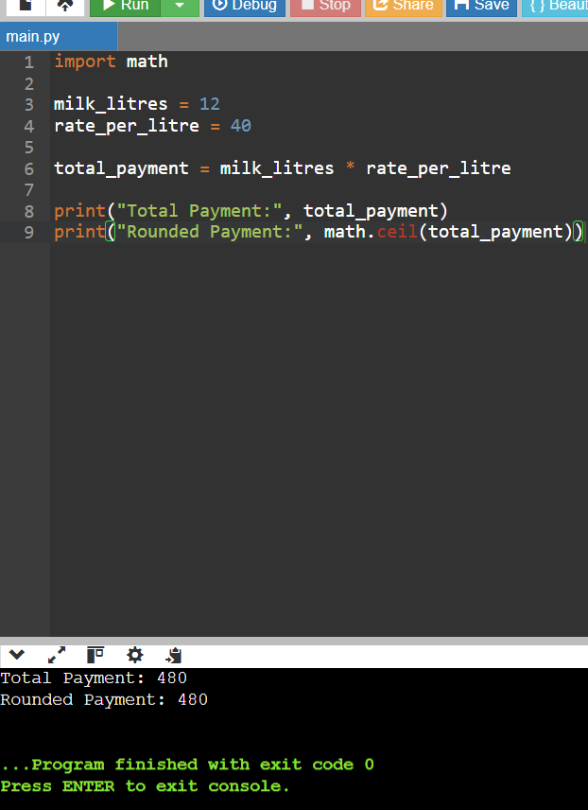

Task 8: Algorithm and Hand Trace:
milk_litres = 5
rate_per_litre = 40

total_payment = milk_litres * rate_per_litre

print("Step 1: Milk Litres =", milk_litres)
print("Step 2: Rate =", rate_per_litre)
print("Step 3: Payment =", total_payment)
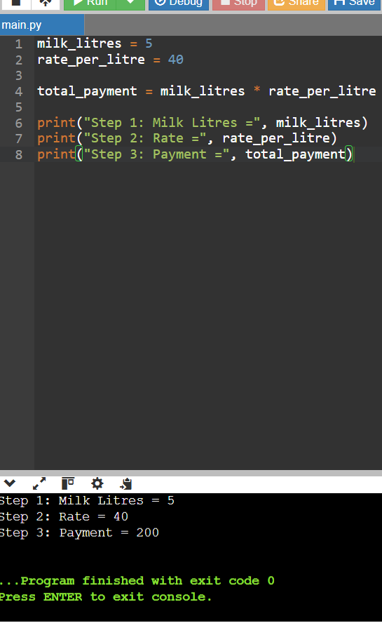

Task 9: Implementation and Testing: def calculate_payment(litres, rate):
if litres < 0 or rate < 0:
return "Invalid input"
return round(litres * rate, 2)

print(calculate_payment(10, 40))
print(calculate_payment(5, 35))
print(calculate_payment(0, 40))
print(calculate_payment(-2, 40))
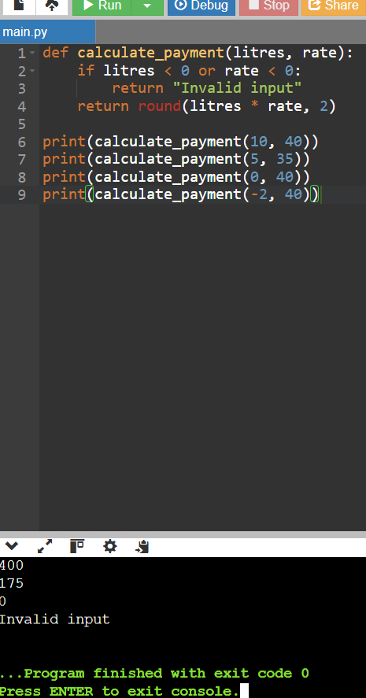

Task 10: Float vs Decimal: from decimal import Decimal
import time

start = time.time()

float_total = 0.0
for i in range(100000):
float_total += 0.1

float_time = time.time() - start

start = time.time()

decimal_total = Decimal("0.0")
for i in range(100000):
decimal_total += Decimal("0.1")

decimal_time = time.time() - start

print("Float Total:", float_total)
print("Decimal Total:", decimal_total)
print("Float Time:", float_time)
print("Decimal Time:", decimal_time)
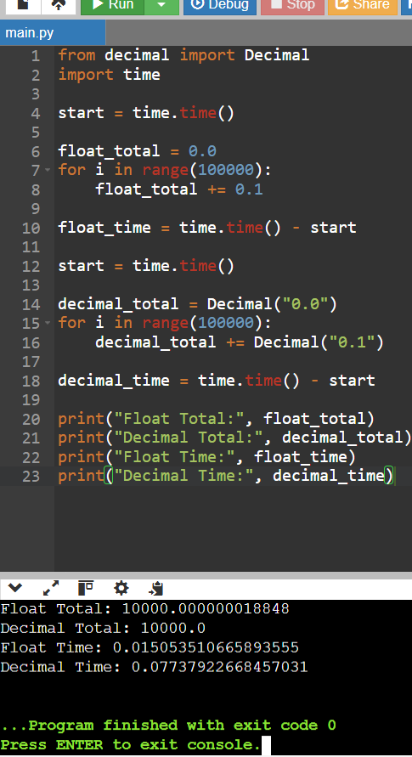

Task 11: Recommended Design:
from decimal import Decimal

def calculate_payment(litres, rate, bonus=Decimal("0.00")):
litres = Decimal(str(litres))
rate = Decimal(str(rate))
bonus = Decimal(str(bonus))

if litres < 0 or rate < 0 or bonus < 0:
raise ValueError("Values cannot be negative")

return (litres * rate + bonus).quantize(Decimal("0.01"))

try:
litres = input("Enter milk quantity: ")
rate = input("Enter rate per litre: ")

payment = calculate_payment(litres, rate)
print("Total Payment: Rs.", payment)

except (ValueError, ArithmeticError):
print("Please enter valid non-negative numbers.")
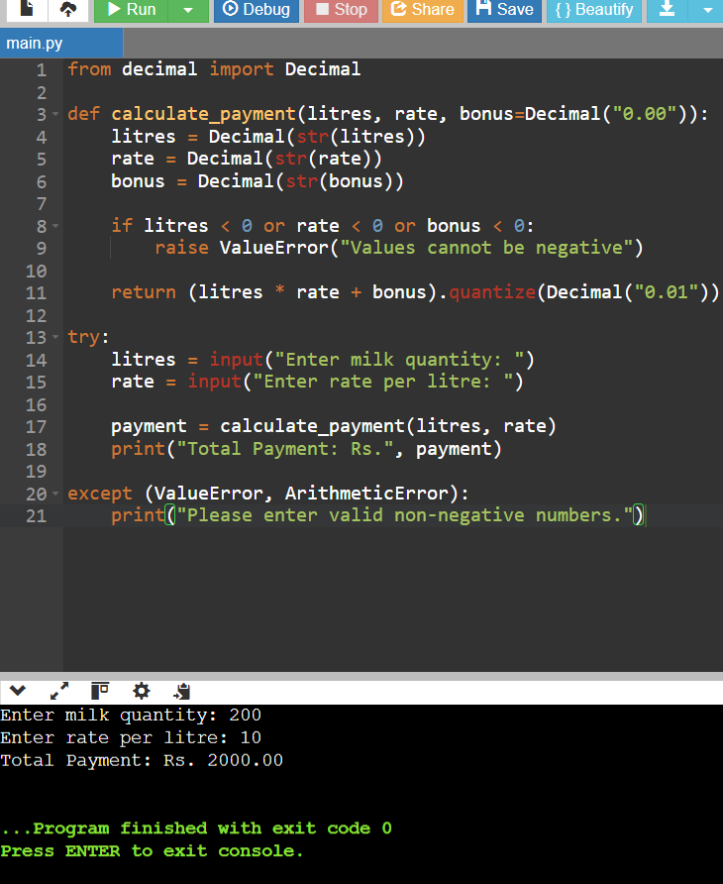

Task 12: Seasonal Rate and Bonus:
def calculate_payment(litres, season):
if season.lower() == "summer":
rate = 45
bonus = 20
elif season.lower() == "winter":
rate = 40
bonus = 10
else:
rate = 42
bonus = 0

total_payment = litres * rate + bonus

return rate, bonus, total_payment

litres = float(input("Enter milk quantity: "))
season = input("Enter season (summer/winter/other): ")

if litres >= 0:
rate, bonus, payment = calculate_payment(litres, season)

print("Rate per Litre:", rate)
print("Bonus:", bonus)
print("Total Payment: Rs.", round(payment, 2))
else:
print("Milk quantity cannot be negative.")
